

**Wireless Networks and Mobile Computing**

Lecturer: Mr. Valens Nsengiyumva

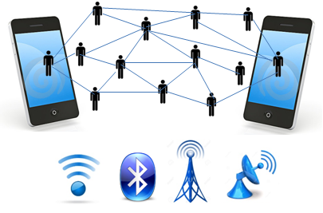

Individual Assignment

Ngeyen Victory

E/BCS/20/09/13354

A **cellular network** or **mobile network** is a communication network where the last link is wireless. The network is distributed over land areas called "**cells**", each served by at least one fixed-location transceiver, but more normally, three cell sites or base transceiver stations. These base stations provide the cell with the network coverage which can be used for transmission of voice, data, and other types of content. A cell typically uses a different set of frequencies from neighboring cells, to avoid interference and provide guaranteed service quality within each cell.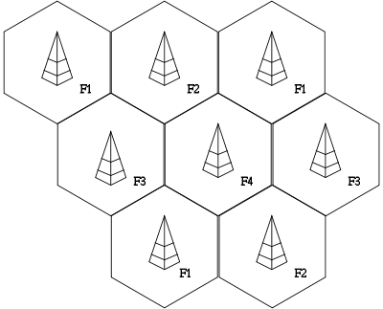

### **Second Generation Cellular Network - 2G**

____________________________________________________________________________________________________________________________________________________________________________________________________________________________________________________________________________________________________________________________________________________________________________________________________________________________

2G is short for second-generation cellular networks. 2G cellular networks were commercially launched on the GSM standard in Finland by Radiolinja in 1991. The capacity limitations, the quality issues and the limitations to rather national mobile communication standards of the first analogue mobile communication systems led to the development of a 2nd generation of digital cellular mobile communication systems.

#### **How 2G Works**

There are three different types of technologies in the second generation : FDMA (Frequency Division Multiple Access), TDMA (Time Division Multiple Access) and CDMA (Code Division Multiple Access). All types have one common feature of multiple access which means that many users are able to use the same number of cells. First part of all the technologies makes a difference

1. **Frequency Division Multiple Access (FDMA)**

Frequency Division Multiple Access (FDMA) enables the calls to use different frequencies by splitting it into small cells. Each call uses a different frequency. The phenomenon is the same as in radio where different channels broadcast on separate frequency. So every radio station has been assigned different frequencies according to the specific band available. FDMA is best in case of analog transmission but also supports digital transmission. No doubt it is accommodating to the digital signals yet with poor service

1. **Time Division Multiple Access (TDMA)**

TDMA is a narrow band of 30 KHz wide and 6.7 millisecond long. It is divided into three slots of time. Using the CODEC, stands for Compression / Decompression algorithm, compresses the digital information and uses less space leaving for the other users. Division of this narrow band into three time slots increases the capacity of the frequency band. TDMA supports both frequency bands IS-54 and IS-136. GSM (TDMA) is a different standard and provides a basis for IDEN and PCS. Being an international standard, it covers many countries of the world. There is only the need for changing the SIM and you can get connected no need to buy a new phone. Having two different bands

|  |  |
| --- | --- |
| **Advantages** | **Disadvantages** |
| 1. 2G technology offers improved privacy that was not possible with the earlier technologies 2. The digital calls tend to be free of static & background noise , The digital signals require very little battery power 3. The mobile batteries can last longer as the digital signals consume less battery power 4. 2G technology introduces the digital data services such as SMS & email | 1. The weaker digital signal transmitted by the cellular phone can not be sufficient to reach the cell tower in less populous areas 2. The digital signal has jagged decay curve , unlike the Analog that has a smooth decay curve 3. The digital will start to completely fail , by dropping calls or being unintelligible 4. the use of lossy compression by the codecs takes a toll and the range of sound that they transmit is reduced |

### **Third Generation Cellular Network - 3G**

____________________________________________________________________________________________________________________________________________________________________________________________________________________________________________________________________________________________________________________________________________________________________________________________________________________________________________________________________________________________________________________________________________________________

3G (short for third generation) is the third generation of wireless mobile telecommunications technology. It is the upgrade for 2.5G GPRS and 2.75G EDGE networks, for faster data transfer. This is based on a set of standards used for mobile devices and mobile telecommunications use services and networks that comply with the International Mobile Telecommunications-2000 (IMT-2000) specifications by the International Telecommunication Union.3G appeared in 2001. It offers services such as downloading programs, exchanging emails, and instant messaging. They had more security than the 2G, and the speed reached 2048 kbit / s (2 Mbit / s).

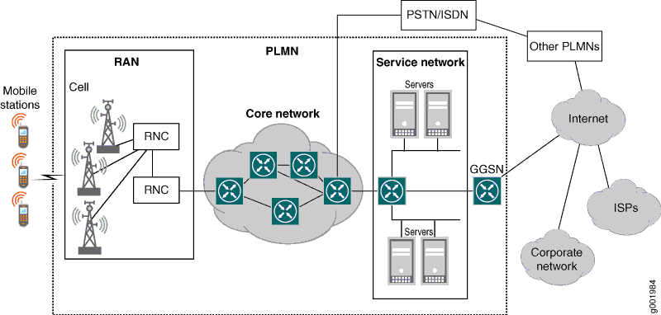

#### **How It works**

Three important technologies which make the 3G standard are CDMA 2000, WCDMA (UMTS), and TD-SCDMA. The prominent features after the integration of high capability technologies are like high speed data transfer rate at 3Mbps prop up the usage of the internet. It’s the matter of your need now to which mode you want to switch to PC, internet, or phone mode, simply it’s a 3 in 1. Let's see the technologies used in 3G and their function and how they work.

**Code Division Multiple Access (CDMA 2000)**

Code Division Multiple Access 2000 is approved by 3GPP2 Organization. CDMA200 hybrid with IS-95 B provides an unlimited access to IMT-200 Band as well as CDMA 200 1x and ideal conditions for the highest data transfer rate. The CDMA 2000 1x evolves into CDMA 200 1x EV. This cdma 200 1x EV IS put into service in two different forms;

* CDMA 2000 1x EV-DO- 1X Evolution data only able to use 1.25 MHz
* CDMA 2000 1x EV-DV- 1x Evolution Data and Voice also use 1.25 MHz

All these versions are supposed to attain the highest speed for greater efficiency of the mobile phones.

**Wideband-CDMA/ Universal Mobile Telecommunications System (W-CDMA / UMTS)**

3G mobile technology has been marked by the CDMA accomplishment. ETSI Alpha group develops this technology on radio access methods. W-CDMA offers challenges in shapes of versatility and complexity of its design. Its multifaceted single algorithm made the complete system more difficult hence the receiver becomes a more complex device. It provides a friendly environment to the multi-users with greater simulation and broader interface able to transfer data with time variations.

|  |  |
| --- | --- |
| **Advantages** | **Disadvantages** |
| 1. Faster data rates. 2. Support multimedia applications such as video and photography. 3. Value added services like mobile television, GPS, video call and video conference. 4. High speed mobile internet access. 5. Increased capacity. | 1. Requires 3G compatible handsets. 2. The cost of upgrading to 3G device is expensive. 3. Power consumption is high. 4. 3G requires closer base stations which is expensive. |
|
|
|
|

### **4G Cellular Network**

____________________________________________________________________________________________________________________________________________________________________________________________________________________________________________________________________________________________________________________________________________________________________________________________________________________________________________________________________________________________________________________________________________________________

4G is a mobile communications standard intended to replace 3G, allowing wireless internet access at a much higher speed. The expectation for the 4G technology is basically the high quality audio/video streaming over end to end Internet Protocol. If the Internet Protocol (IP) multimedia subsystem movement achieves what it going to do, nothing of this possibly will matter. WiMAX or mobile structural design will become progressively more translucent, and therefore the acceptance of several architectures by a particular network operator ever more common. The technologies that fall in the 4G categories are UMTS, OFDM, SDR, TD-SCDMA, MIMO and WiMAX to some extent.

#### **Features**

A few of the expected issues considered to be resolved in the 4G mobile technology rollout are as follows

1. It is considered to embed IP features in the set for more security purposes as high data rates are sent and received through the phone using 4G mobile technology.
2. 4G mobile technology is going to be able to download at a rate of 100Mbps like mobile access and less mobility of 1GBps for local access of wireless
3. Instead of hybrid technology used in 3G with the combination of CDMA and IS-95 a new technology OFDMA is introduced in 4G. In OFDMA, the concept is again of division multiple accesses but this is neither time like TDMA nor code divided CDMA rather frequency domain equalization process symbolizes as OFDMA.
4. CDMA sends data through one channel but with the division of time in three slots. While CDMA also sends data through one channel identifying the receiver with the help of code. Whereas in 4G mobile technology OFDMA is going to introduce data packets sent by dividing the channel into a narrow band for the greater efficiency comprises a prominent feature of 4G mobile technology.
5. IPv6 was approved by Verizon as a 4G standard in June 2009.

#### **How 4G works**

There are two main types of 4G, each of which offers a different speed:

1. **4G LTE (Long Term Evolution):** offers a typical download speed of 20Mbps and a theoretical download speed of 150Mbps. This would allow you to download a 500MB file in under 4 minutes.
2. **4G LTE-Advanced:** offers a typical download speed of 42Mbps and a theoretical download speed of 300Mbps. This would allow you to download a 500MB file in just under 2 minutes.

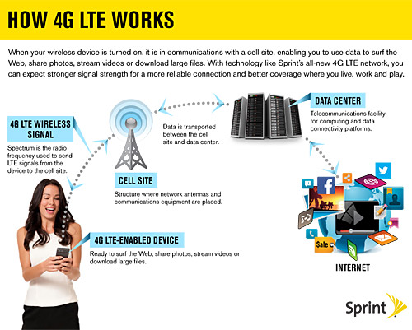

Like 3G, 4G is a protocol that sends and receives data in packets. However, 4G differs from 3G in how it works. 4G is entirely IP based, which means it uses internet protocols even for voice data. Conforming to this one standard means it is less likely for data to become scrambled while traversing the various networks, meaning a more seamless experience for us users! Like all mobile broadband, 4G works through your device communicating with a base station. Base stations are technical speak for the masts that we’ve all seen popping up throughout the country. This mast relays data from your device to the internet and back again.

One of the aspects that makes 4G an upgrade to 3G is its higher capacity. 4G can support a greater number of users, even at peak times. For example, a 3G tower may only be able to give 100 people the best possible connection speed, but a 4G tower can theoretically give 400 people the best service.

|  |  |
| --- | --- |
| **Advantages** | **Disadvantages** |
| 1. Quickly download files over a wireless network 2. Extremely high voice quality 3. Easily access Internet, IM, social networks, streaming media, video calling 4. Higher bandwidth 5. 4G is 10 times faster than 3G | 1. New frequencies means new components in cell towers. 2. Higher data prices for consumers 3. Consumer is forced to buy a new device to support the 4G 4. It is impossible to make your current equipment compatible with the 4G network |

### **Fifth Generation 5G Network**

Fifth-generation wireless (5G) is the latest iteration of cellular technology, engineered to greatly increase the speed and responsiveness of wireless networks. With 5G, data transmitted over wireless broadband connections can travel at multigigabit speeds, with potential peak speeds as high as 20 gigabits per second (Gbps) by some estimates.

The 5G network is assumed as the perfection level of wireless communication in mobile technology. Cable networks have now become the memory of the past. Mobiles are not only a communication tool but also serve many other purposes. All the previous wireless technologies are entertaining the ease of telephone and data sharing but 5G is bringing a new touch and making the life real mobile life. The new 5G network is expected to improve the services and applications offered by it.

#### **Features**

5G is driven by 8 requirements. These requirements are listed below

1. 1-10Gbps connections to end points in the field (i.e. not theoretical maximum)
2. 1 millisecond end-to-end round trip delay - latency
3. 1000x bandwidth per unit area
4. 10-100x number of connected devices
5. Perception of) 99.999% availability
6. Perception of 100% coverage
7. 90% reduction in network energy usage
8. Up to ten year battery life for low power, machine-type devices

#### **How 5G works**

5G network architecture illustrating 5G and 4G working together, with central and local servers providing faster content to users and low latency applications. A mobile network has two main components, the ‘Radio Access Network’ and the ‘Core Network’.

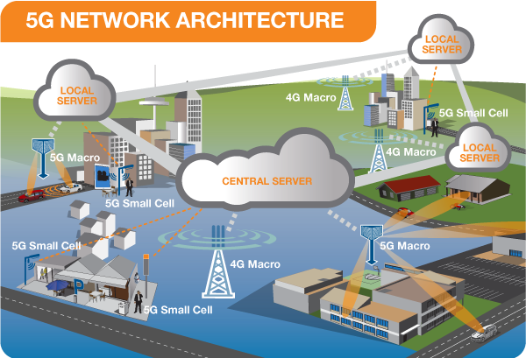

**The Radio Access Network** - consists of various types of facilities including small cells, towers, masts and dedicated in-building and home systems that connect mobile users and wireless devices to the main core network.

Small cells will be a major feature of 5G networks particularly at the new millimetre wave (mmWave) frequencies where the connection range is very short. To provide a continuous connection, small cells will be distributed in clusters depending on where users require connection which will complement the macro network that provides wide-area coverage. 5G Macro Cells will use MIMO (multiple input, multiple output) antennas that have multiple elements or connections to send and receive more data simultaneously. The benefit to users is that more people can simultaneously connect to the network and maintain high throughput. Where MIMO antennas use very large numbers of antenna elements they are often referred to as ‘massive MIMO’, however, the physical size is similar to existing 3G and 4G base station antennas.

**The Core Network** - is the mobile exchange and data network that manages all of the mobile voice, data and internet connections. For 5G, the ‘core network’ is being redesigned to better integrate with the internet and cloud based services and also includes distributed servers across the network improving response times (reducing latency). Many of the advanced features of 5G including network function virtualization and network slicing for different applications and services, will be managed in the core.

#### **Advantages**

As some of us already know, 5g is simply the next generation of mobile carrier services from 4g, which had progressed to 4g LTE. 5g offers 6GHz frequencies, and therefore achieves a faster bandwidth with flexible encoding and bigger channel sizes to achieve a speed of 25 to 50 percent better than LTE. But, thats for normal cell towers. On the other hand, we are speculating an increase in City-wide usage of 5g: with super high bandwidths (ie multi-gigabit speeds, 10GB/s+ depending on your connection) but only a really (I mean really) small range.

#### **Disadvantages**

That brings us to our first few cons:

* Increased Bandwidth equals less coverage
  + When 3g came out, it was particularly useful in covering large areas due to its low bandwidth. Think of it like this: the smaller the range of a tower, the more dense its signal is, therefore a higher bandwidth.
  + As 5g rolls out, the bandwidth will be even smaller, and we would need a larger number increase in the towers we already have.
* Radio frequency may be a problem
  + In essence, the radio frequency by 5g networks are 6GHz, and in that range, it could get crowded by other devices or protocols such as satellite links.
  + People have health concerns on the closer microwaves from some 5g transmitters, as engineers have to sometimes wear lead suits while working on such transmitters.